#1. Create a resuable function to get numbers from the given list

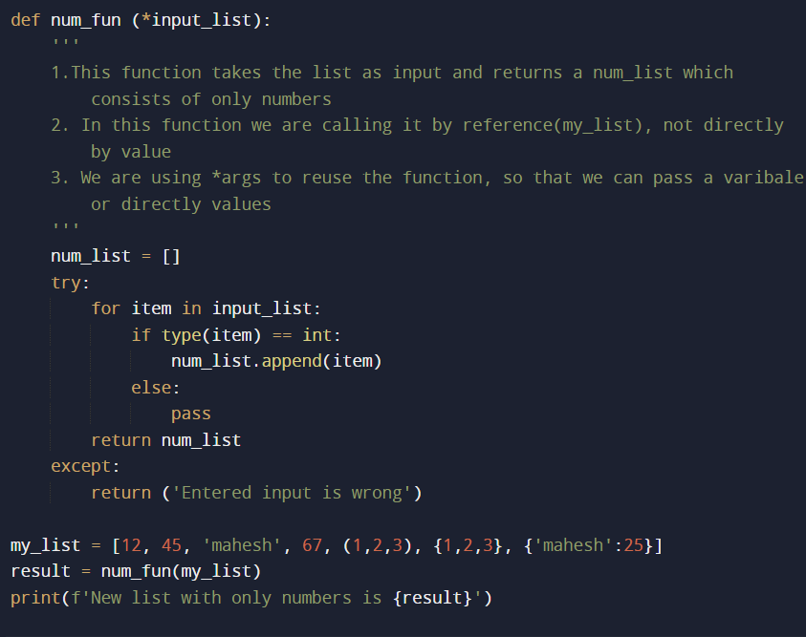

#WE R CALLING THE FUNCTION USING REFERENCE

#OUTPUT



#WE ARE CALLING NOW DIRECTLY MULTIPLE ARGS, INSTEAD OF SENDING LIST

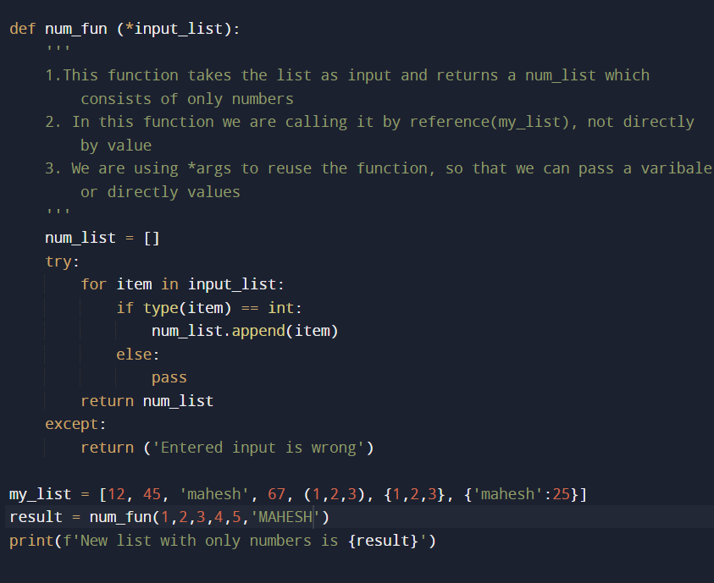

#OUTPUT



#2. Create a resuable function to get sum of the given mixed list

#CALL BY REFERENCE

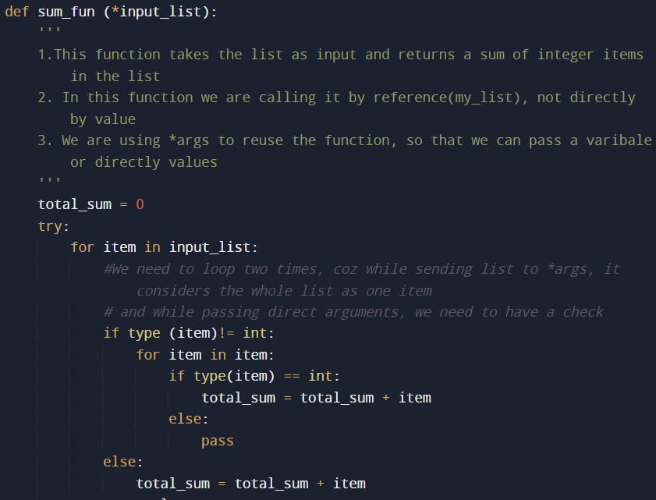

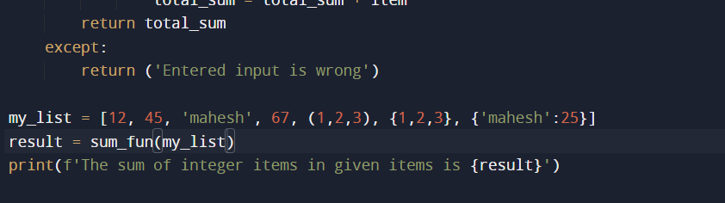

#OUTPUT



#CALL BY VALUE

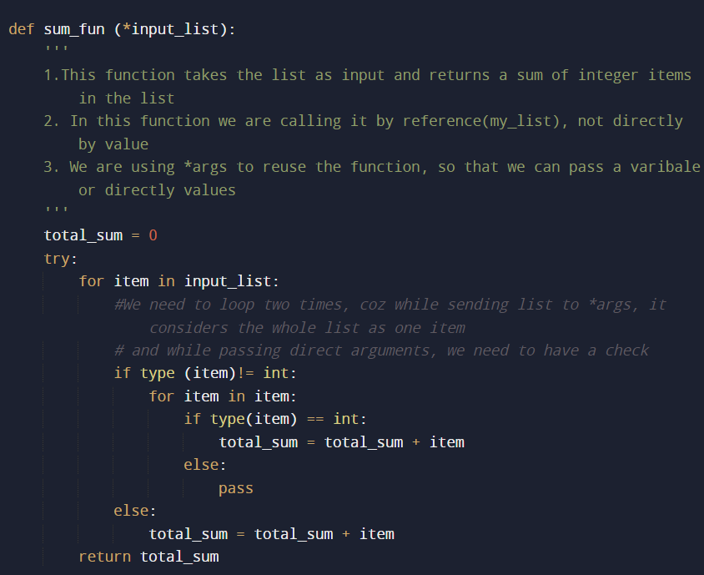

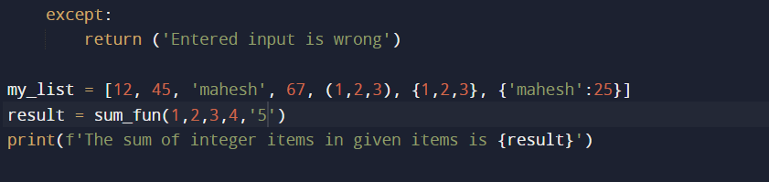

#OUTPUT



#3. Create a resuable function to getthe items count of the given list

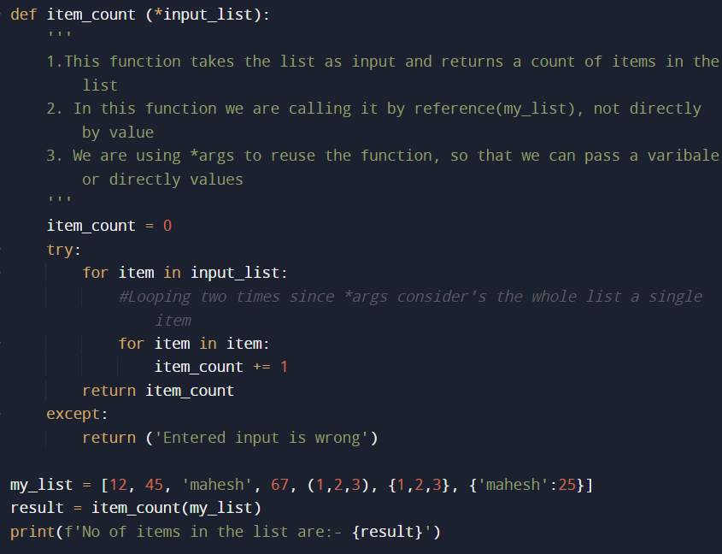

#OUTPUT

